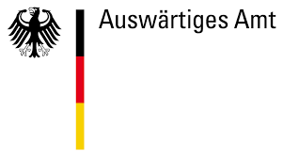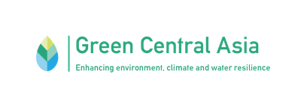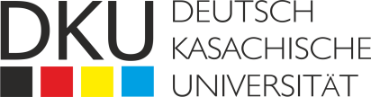

## Товарный знак БАРСАКЕЛМЕС МЕМЛЕКЕТТІК ТАБИҒИ ҚОРЫҒЫ (№ 44769 ...

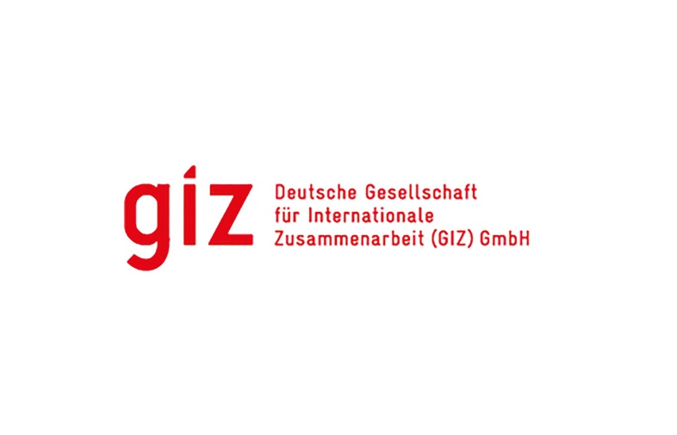

## **5th Summer School on the Aral Sea**

**21–31 August 2023**

**Background**

Aral Sea is one of the most well-known ecological disasters in the world where 4th largest lake in the world has almost disappeared. Such drastic changes influenced not only human living in that area but also the biological community of the region. Both aquatic and terrestrial ecosystems were affected by the sea desiccation and currently vast landscapes have changed. Even though biodiversity of the Aral Sea depleted since 1960s, the ecosystems of the Aral-Syrdarya and Aral-Amurdaria watersheds containing critical lakes, wetlands and coastal ecosystems still is a home for many species, including endemic and red-listed. Desert ecosystems, i.e. Barsa-Kelmes Nature reserve is home for over 278 species of plants, and such rare vertebrate species as kulan, Goitered gazelle, Long-eared hedgehog, White-headed duck, Steppe eagle, Marbled duck. Uzbekistan with support from development agencies put enormous effort in Aral seabed afforestation.

Unsustainable water and land resources management poses continuing risks for this fragile ecosystem. However, both Kazakhstan and Uzbekistan invest into Aral Sea area restoration. Coordinated water resources management and sustainable land management is fundamental for achieving land degradation neutrality and biodiversity conservation. A number of projects and initiatives had been and are implemented in the area by countries directly and with support of development agencies and financial organizations. These efforts for biodiversity conservation need recognition and further replication and dissemination.

Such recognition and knowledge share can be arranged through Aral Sea summer school. Kazakh-German University (DKU) has successfully arranged annual Aral Sea summer school since 2019 shifting the aspect of the school thematic each year. 80 young scientists, government officials and civil activists gained knowledge and experience from Aral Sea summer school 2019-2022, further applying received knowledge in their respective areas. The Aral Sea summer school is growing in recognition, about 800 people applied to participate in 2022.

Kazakh-German University (DKU) closely cooperates with the International Fund for Saving the Aral Sea (IFAS). IFAS was created as the response to the biggest accidents of the XX era in order to reduce the environmental crisis and improve the socio-economic situation in the Aral Sea basin in 1993. This year IFAS will be celebrating its 30th anniversary of work. The Aral summer school is supported by IFAS as one of the national and regional events in the IFAS Founding States and is incorporated in its workplan of celebration of 30 years anniversary.

Having successfully accomplished goals of the previous Aral Sea summer schools in 2019-2022 years, DKU was able to fulfill the aim on supporting nature-based solutions approach towards environmental challenges. In committing to achieve Sustainable Development Goals (SDGs), DKU aims to implement its summer schools on an annual basis, focusing on the themes of SDG 14 "Life below water", SDG 15 "Life on land", United Nations World Water Development reports, and IPCC reports. Consequently, the goal of the 2023 Aral Sea summer school is to put emphasis on the Biodiversity conservation effort in the area of the Aral Sea, and to serve youth – one of the most vulnerable groups as specified in the 2030 Agenda.

The young water and climate leaders of the Central Asian region are potential future decision-makers, representatives of academia and research, who will influence the development of the region and beyond. Thereby, we aim that the summer school will be a tool to empower and inspire the youth to choose nature-based solutions when addressing environmental challenges. We will lead an expert-to-youth knowledge exchange, as well as capacity-building and networking opportunities for future water and climate leaders. It is crucial to raise awareness not only about the Aral Sea desiccation and how this man-made environmental tragedy continues to affect the local population, who had to migrate and leave their homes, but about its influence on all living things from aquatic invertebrates and fish to plants, birds, and mammals. What is more important is to talk about the effort taken to prevent or revive the biodiversity loss and how such effort and be replicated on a grander scale.

This year summer school will have a special focus on the Aral Sea area biodiversity, biodiversity conservation effort, and challenges for climate change, irrational water and land resources use poses for biodiversity. Therefore, we envision an added value of the summer school in acknowledging the current situation in the Aral region and attracting more young specialists to engage with the topic in their professional and academic life.

Such summer school falls in line with GIZ 2023 GCA joint operation plan on the discussion of coordination on transboundary protected areas in CA

**Thematic directions of Summer School:**

* **Biodiversity (BD).** This thematic will provide information about biodiversity of the region and valuable ecosystems, and changes in the Aral Sea region flora and fauna. Within this section participants will be introducing with threats for biodiversity from current land and water use practices and global climate change. Summer school students will learn the best practices and lessons learned from projects on biodiversity conservation implemented in the area.
* **Oral History.** Oral history can provide a vital source of information about the past. In the case of the Aral Sea, there are a number of scientific studies that analyze the sea’s collapse. We have far less information about the social and cultural impact of the sea’s regression. This oral history component of the summer school will help students understand how the dramatic environmental upheavals of the last few decades have affected people in the region. These efforts will also provide an important corrective to a literature that has tended to portrayed the Aral Sea story as one of societal collapse. In the West, people affected by the catastrophe are often reduced to stereotypes. They are portrayed in a timeless way, as helpless victims paralyzed by corruption, backwardness and other “legacies” of the Soviet past. Instead, we will highlight the varied ways that Aral Sea residents have responded to climate change and the far-reaching social and economic changes that the disaster produced.
* **IWRM.** Integrated Water Resources Management (IWRM) is a process which promotes the coordinated development and management of water, land and related resources in order to maximise economic and social welfare in an equitable manner without compromising the sustainability of vital ecosystems and the environment. The GWP IWRM Tools are the key concepts and “how-to’s”, that have to be addressed in managing water. The tools encompass an array of resources stemming from technical and academic resources, official documents and GWP publications. 5th Aral Summer School will include theory and practical field studies in order to implement short case studies in the region of Aral.

Thematic scopes will be structured to develop a better understanding of biodiversity conservation efforts, transboundary and regional cooperation, IWRM approach in the region as well as discover the potential of youth for water and peace based on the history of the region.

**Methodology**

Expert-to-youth knowledge exchange, as well as capacity-building and networking opportunities for future water, biodiversity, and climate leaders will be conducted. The summer school will be based on interactive thematic lectures, which then will be followed by working sessions to foster intergenerational dialogue and build the capacities of the participants. Field trips around the Aral Sea Basin provided an opportunity for the engagement of youth with the local community and interaction with civil society, which was an essential part of the experience and traditional knowledge sharing.

The agenda of the summers school includes one-two days of the theoretical preparation (lectures from the experts), five-seven days of the field visits (including field lectures, excursions, cultural events, etc.), and one day of the wrap-up session with the presentations from students with their ideas for the water issues solutions based on the collected information during the summer school.

The theoretical part will be supported by practical part via visits on project sites. During participation in the Summer School, participants will visit some of those projects sites and talk in person with projects representatives. Whereas field experts, researchers, and international organization representatives will be invited to speak with the participants and share their knowledge and experience.

The list of potential site visit include:

* Pilot sites of the GIZ project “Ecologically Oriented Regional Development in the Aral Sea Region”, that strives to support Kazakhstan and Uzbekistan Micro-, Small and Medium-sized Enterprises in the Aral Sea area
* Projects implemented with the support from GEF SGP (Global Environmental Facility Small Grants Program):
* Public Fund “Aral Tenizi” “Development of the fishery on Tuschi lake as example of decreasing of anthropogenic pressure on biodiversity of wetland lakes”
* Public Association “Kamystybas” “Biodiversity conservation on Syrdarya river via use of better fish catchment equipment”
* Public Association Aral Aeldery “Pond fishery development in the Amanotkel village as method to conserve biodiversity and fish production of natural lakes of Syrdaria watershed”
* USAID Regional Water and Vulnerable Environment activity (WAVE) site of the seabed afforestation
* Visit to Kok-Aral Dam as major element for Northern Sea revival and return of some fish species into the Sea and fish industry recovery. (Kor-Aral Dam was built by Government of Kazakhstan with loan from the World Bank)
* With enough funds it might be possible to cooperate with Uzbekisnta partners for the site visit of the afforested areas of Aral seabed, and GIZ ValuES project on the Aral Sea Wetland Restoration Strategy, potential pilot sites for environmental-friendly brine shrimp Artemia production in the Aral Sea region (in the Republic of Karakalpakstan).
* Barsakelmes Nature reserve,
* Kambash lake project on eco-truism as an alternative to source of income for local population (preventing illegal fishing).

Additionally plausible to visit other projects sites where projects by FAO, and World Bank were implemented.

Regarding the oral history of the region, the lectures also will be supported by the field research. First, we will meet with the students to discuss oral history as a methodology. We will talk about some of the challenges of this approach and its benefits and drawbacks. I may also provide the students with one or two short readings about oral history as a methodology to get the discussion going. Then, we will agree upon a list of questions for each interviewee. These may include: When did you begin to notice that the sea was disappearing? How did you respond? Why did you decide to stay (or leave) the region? How do you cope with the Aral Sea’s environment (dust storms, increased heat)? How has the construction of a dam on the Kazakhstani side changed your way of life?

Students will then work in small groups to conduct interviews. They will ask each respondent for permission to interview and record them. If a respondent does not wish use to use their real name in the interview, we can use a pseudonym.

After these interviews have conducted, we will all return together to discuss our findings. We will consider issues such as: How representative are these interviews? Can we generalize from them to reach certain conclusions? Or are there important social groups and perspectives that we are missing? How do you think a respondent’s social position, such as economic employment, gender, age, etc, might affect their answers? Do you think a city bureaucrat might respond differently than a local fisherman? Does it matter who carried out the interviews? If the interview was carried out by a man or a foreigner, do you think that your respondent would have framed their answers differently if the interviewer was a woman or a local resident?

**Objectives**

* Expand knowledge of future water leaders in the field of biodiversity conservation, sustainable natural resources management, climate change and impotence of the oral history of the Aral Sea region;
* Expand knowledge and case study skills of participants through theoretical and practical field lectures using GWP toolboxes in the area of Integrated Water Resource Management;
* Expand importance of the biodiversity of the region and efforts for its conservation ;
* Raise awareness of the youth through strengthening a platform for networking to create ties between different youth initiatives and allow new, concrete actions to emerge in the region and beyond;
* Promote dialogue between the youth and civil society.

**Audience**

The Summer School addresses dedicated young professionals and students with an interest in Integrated Water and Land Resources Management and its practical implementation in policymaking. Eligible are participants from the following Central Asian countries: Kazakhstan, Kyrgyzstan, Tajikistan, Turkmenistan, Uzbekistan, as well as Afghan students currently residing only in Kazakhstan. The representatives of Water UNESCO Chairs over the globe and UNESCO-IHP program partners will be also invited for the participation in the Summer School.