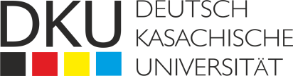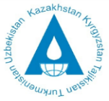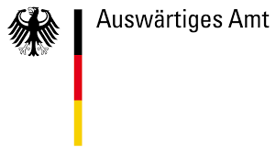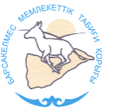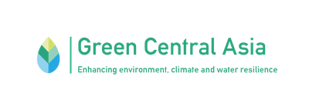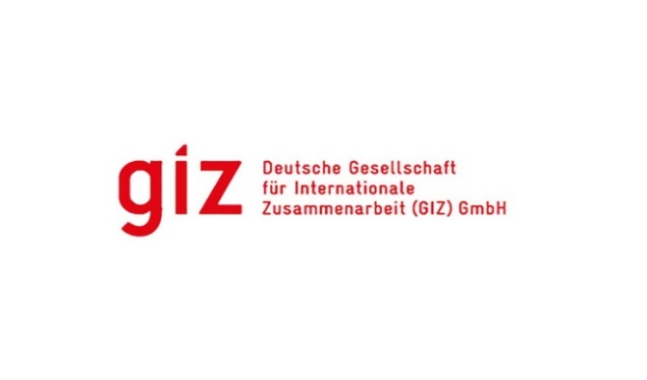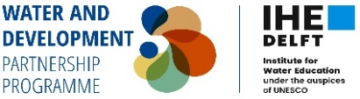

**6th Aral Sea Summer School**

**August 12-22, 2024**

**Introduction**

The Aral Sea is one of Earth's largest bodies of water in Central Asia, whose volume has decreased almost 10-fold over the past few decades. This progressive desiccation has turned the territory of the Aral Sea region into one of the most famous environmental disasters. The impact of negative transformations of the Aral Sea has profound consequences not only for the ecology but also for the economic and social situations in the Central Asian region.

Irrigation regulation during the 1960s of the largest transboundary rivers, Syrdarya and Amudarya, did not consider the consequences of irrigation on the fragile desert ecosystems of the region. As a result, there was a catastrophic decrease in the reservoir and the water level. By the end of the 1980s, the Aral Sea was divided into the Northern Small Aral and the Southern Big Aral. The increasing rate of extinction in the sea has caused serious changes in the ecological state of the region:

increasing desertification, land salinization and degradation of water bodies, depletion of flora and fauna, increasing frequency of dust storms from the dried seabed. Abrupt climate change, which has become noticeable in Central Asia and other regions, can be considered a direct consequence of the Aral Sea drying up. The consequences of the disappearance of the Aral Sea for the economies of the countries of the region are also quite significant. Due to losing fishing and transportation potential, fish processing and ship repair enterprises have ceased to operate. The agricultural sector has suffered great damage. Deterioration of soil quality and reduction of water resources led to v crop and fodder yields. Children's camps and vacation homes on the seashore disappeared. Losses have affected economic sectors and incomes in the region, especially in Kazakhstan and Uzbekistan, including Karakalpakstan. Environmental problems and economic destabilization have manifested themselves in worsening living conditions for nearly 2 million people living in the Aral Sea region. There has been a steady increase in morbidity, loss of traditional ways of life, and migration of the population to territories with better living conditions and sources of income.

It should be noted that several government projects and initiatives, supported by development agencies and financial organizations, are already implementing solutions to these difficult issues and serious concerns in Kazakhstan and Uzbekistan. Coordinated sustainable management of water and land resources is fundamental for improving the environmental and socio-economic situation of the Aral Sea region. These efforts need to be recognized and further disseminated to ensure their success.

The Kazakh-German University (DKU) has successfully held the annual Aral Summer School since 2019. It has increased the range of themes year over year. This event has become a solid foundation for disseminating and exchanging knowledge. From 2019 to 2023, approximately 100 young scientists, civil servants, and civil activists deepened their knowledge and experience on the Aral Sea through our Summer School, applying their new-found expertise in their respective fields. As a result, the Aral Summer School is only becoming more renowned. Year after year, more and more people from Central Asia, and now, in 2024 - from Mongolia apply to participate.

KNU conducts its Aral Summer schools under the auspices of achieving commitments under the Sustainable Development Goals (SDGs) - 14: "Conservation of marine ecosystems", 15: "Conservation of terrestrial ecosystems", 13: "Combating climate change", 3: "Good health and well-being", 8: "Decent work and economic growth". Based on this framework, the goal of the Aral Summer School 2024 is to focus on efforts to improve the socio-economic and environmental situation in the Aral Sea basin and serve the development of youth – one of the most vulnerable groups, as indicated in the 2030 Agenda.

Realizing the need to restore ecosystems and socio-economic well-being of the region, the leaders of Uzbekistan, Kazakhstan, Kyrgyzstan, Tajikistan and Turkmenistan established the International Fund for Saving the Aral Sea (IFAS) in 1993. The long-term cooperation of the Kazakh-German University (KNU) and the IFAS Executive Directorate contributes to raising awareness among the participants of the Aral Summer School about the situation in the Aral Sea region and its impact on climate change, ecosystem dynamics and the quality of life of the population.

The young environmental, climate and water leaders of the Central Asian region are future potential decision-makers. These representatives of academic and scientific circles will influence the region's development and beyond. Thus, we strive for the summer school to become a tool that will empower and inspire young people to choose the best ways to solve environmental, economic and social problems. We will lead knowledge exchange between experts and youth and provide capacity-building and networking opportunities for future leaders in these fields. It is extremely important to raise awareness not only about the desiccation of the Aral Sea but also about how this man-made environmental tragedy continues to affect the development of ecosystems and the local population. We consider it particularly important to talk about the efforts to restore ecological balance and socio-economic stability and how they can be replicated on a larger scale.

This year, the summer school will pay special attention to the socio-economic characteristics of the Aral Sea region and problems related to climate change and unsustainable use of water and land resources, which negatively impact the region's development. Additional topics this year will be raising awareness about the relationship between the dynamics of the cryosphere of Central Asia and water resources, the risks of natural disasters, integrated water resources management and the specifics of tourism for the region's development. Therefore, we see the additional value of summer school in recognizing the current situation in the Aral Sea region and attracting more young professionals to participate in this topic in their professional and academic lives.

The 6th Aral Summer School corresponds to the partnership plan with GIZ within the framework of the Green Central Asia initiative and with the Delft Institute of Water Education IHE within the framework of the ASB&LCB SPACE project.

**Goals**

● Expand future leaders' knowledge about climate change and its implications for Central Asia's water, food and socio-economic security.

● Expand participants' knowledge and skills in our case study through theoretical and practical field lectures using the Global Water Partnership (GWP) toolkits in integrated water resources management.

● Raise awareness among young people by strengthening the platform for connecting various youth initiatives and enabling new concrete measures in the region and beyond.

● Promote dialogue between youth, civil society, research organizations and international projects.

● Highlight events on KNU’s social networks to ensure greater visibility and opportunities for interregional cooperation.

**Thematic areas of the 6th Aral Summer School:**

● **Climate change.** According to the generally accepted definition, climate change is long-term changes in average weather conditions, including temperature, precipitation, and wind patterns, occurring over decades or longer. These changes are largely caused by human activities, especially greenhouse gas emissions such as carbon dioxide, methane and nitrous oxide. As of 2022, the increase in global climate warming over the previous few decades amounts to 0.86 °C, but by the end of 2023, it rapidly added about 0.5 °C. Starting from June 2023, a record average temperature has been recorded on the Earth's surface for several months. It is necessary to study this topic in the context of the relationship of climate change with the dynamics of the cryosphere of Central Asia and water resources, taking into account the risks of natural disasters and negative processes. This will make it possible to develop effective strategies for adaptation to climate change and water and food security. Participants will also learn about threats to water security for the population of the Lake Chad basin, which repeats the fate of the Aral Sea.

● **Integrated Water Resources Management (IWRM).** Integrated water resources management (IWRM) is a process that promotes the coordinated development and management of water, land, and related resources to maximize economic and social well-being on an equitable basis without compromising the sustainability of vital ecosystems and the environment. The Global Water Partnership (GWP) IWRM tools are key concepts and practical recommendations that must be considered when managing water resources. The tools cover a variety of resources based on technical and academic resources, official documents, and GWP publications. Participants will get acquainted with the current state of the basin with their own eyes, study aspects of water policy, and learn about the importance of coordinated development and management of water, land and related resources.

● **Socio-economic features of the development of the Aral Sea region.** The study of socio-economic problems as the consequences of an environmental disaster helps to understand the complex interrelationships between environmental changes and socio-economic processes and develop effective strategies for sustainable development and improving the quality of life of the local population. Infrastructural, managerial and coordination difficulties require an integrated approach and coordinated efforts to solve them. Investments in infrastructure, health and education are needed, as well as the introduction of sustainable farming practices and international cooperation to improve the living conditions of the local population and restore the ecosystem. Participants will study the socio-economic situation of the region and explore the gender and cultural aspects of local communities, as well as ways to develop and improve the well-being of the population.

● **Tourism in the Aral Sea region**. This area is devoted to the characterization of water resources and socio-economic challenges in the context of their impact on tourism development in the Aral Sea region. The main focus is on the state of the water resource and socio-economic spheres, their sustainability problems and interaction with the tourist infrastructure in the context of global changes and external influences. In order to support the conservation of the unique resources of the region and its heritage, the benefits of obtaining the status of a UNESCO Global Geopark should be considered and discussed. The participants will be presented with the geographical features and heritage of the Kazakh Aral Sea region, socio-economic challenges and opportunities for tourism, the role of tourism in the sustainable development of the region, and the interaction of ecotourism with nature protection. This will allow us to study the specifics of organizing such tourist destinations on the drained bottom of the Aral Sea as "Ecotourism" and "Gloomy tourism" and their benefits for the region's development.

The 6th Aral Summer School will include theoretical and practical field studies to implement brief case studies in the Aral region.

**Methodology**

There will be knowledge sharing between experts and youth, as well as capacity building and networking for future leaders in climate change, water resources and socio-economic challenges. The summer school will be based on interactive thematic lectures, followed by working sessions to promote dialogue between generations and develop the potential of participants. Field trips around the Aral Sea basin allowed young people to interact with the local community and civil society, which was an important part of the exchange of experience and traditional knowledge.

The summer school program includes one to two days of theoretical training (lectures from experts), five to seven days of field trips (including field lectures, excursions, cultural events, etc.) and one day of summing up. A preparatory session with presentations by students with their ideas for solving water problems based on information collected during the summer school.

The practical part will support the theoretical part by visiting the project sites. During the Summer School, participants will visit some of these projects and personally communicate with representatives of the projects and local communities. At the same time, field experts, researchers, and representatives of international organizations will be invited to communicate with participants and share their knowledge and experience.

**The list of places of potential visits includes:**

A visit to the UNDP Green Belt project site in the Aralkum settlement

Kamyshlybash Public Association and its activities in the implementation of improved fishing technologies.

The Public Fund "Aral Tenizi" and its activities for the development of fisheries on Lake Tuschi

Visit the Kok-Aral and the Aklak hydroelectric dams, which are the main hydraulic structures for the revival of the North Sea, restoration of ecosystems, and restoration of the fishing industry (the Government of Kazakhstan built the Kor-Aral dam with a loan from the World Bank).

Barsakelmes Nature Reserve.

A visit to the Northern coast of the Bay of Butakov and the village of Zhalanash is a possible location for developing ecotourism and gloomy tourism and their benefits for the local population.

In addition, it is possible to visit other sites and pilot sites where projects have been implemented with the support of the GEF SGP (Global Environment Facility Small Grants Program), USAID on Water Resources and Vulnerable Environment (WAVE), GIZ "Environmentally Oriented Regional Development in the Aral Sea region" aimed at supporting Kazakhstani and Uzbek micro, small and medium-sized enterprises in the Aral Sea region.

**Participants**

The Summer School is designed for young professionals and students interested in integrated water and land management and its practical implementation in policy development. Participants from the following Central Asian countries are invited: Kazakhstan, Kyrgyzstan, Tajikistan, Turkmenistan, and Uzbekistan, as well as Afghan students currently living in Kazakhstan. UNESCO/UNITWIN network partners will also be invited to participate in the Summer School.