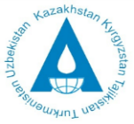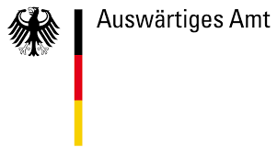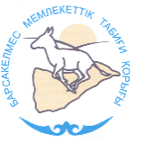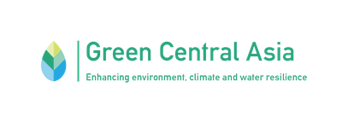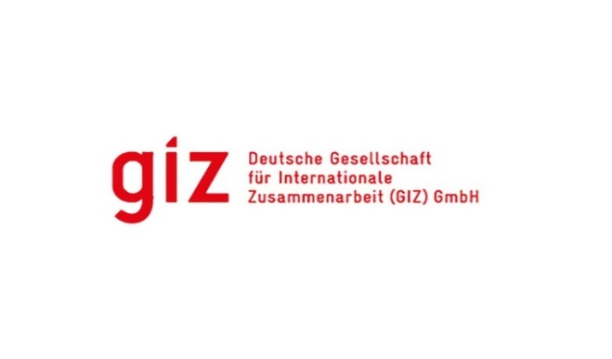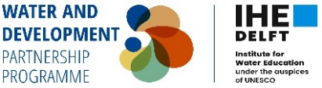

## **7th Aral Sea Summer School**

## **August 15–24, 2025**

**Introduction**

The Aral Sea, once one of the largest water ecosystems in Central Asia, has seen its volume shrink nearly tenfold in recent decades, resulting in one of the most severe environmental disasters of modern times. This crisis has had a significant impact not only on the environment but also on the socio-economic situation in the region.

The disruption of the natural water balance, due to regulation of the transboundary Syr Darya and Amu Darya rivers in the mid-20th century, led to desertification, land degradation, increased frequency of dust storms, and declining water quality. The shrinking of the water body resulted in the collapse of the fishing industry, reduced agricultural productivity, and worsened living conditions for the local population. Today, about 2 million people in the region are suffering from the consequences of the water crisis, including deteriorating health and forced migration.

Despite these large-scale challenges, Kazakhstan and Uzbekistan are actively working to restore the Aral Sea ecosystem through projects focused on water resource management, sustainable agriculture, and land reclamation. Since October 2024, 1 billion cubic meters of water have been directed into the Northern Aral Sea — 100 million more than planned. By the end of 2025, the water volume in the Northern Aral is expected to reach 23.4 billion cubic meters, and the surface area over 3,100 square kilometers. These measures are helping reduce water salinity and restore the population of 22 fish species, which has led to an increase in fish harvests to 8,000 tons per year.

Since 2019, the Kazakh-German University (DKU), together with international and local partners (including funding from the German Federal Foreign Office, IHE Delft, the Executive Committee of the International Fund for Saving the Aral Sea in Kazakhstan, Barsakelmes State Nature Reserve, and GIZ), has been organizing annual summer schools at the Aral Sea. These schools engage young professionals, scientists, and civil society in studying and addressing regional issues.

In 2025, the 7th Aral Summer School will focus on modern approaches to ecosystem restoration, climate change adaptation, and sustainable water and land management. It will serve as a platform for cultivating a new generation of environmental, climate, and water leaders in Central Asia. Increasing awareness, developing practical skills, and engaging in real-world projects will empower young professionals to contribute to sustainable regional development and create effective solutions for preserving natural and water resources.

The Summer School is organized with support from GIZ under the Green Central Asia initiative and IHE Delft within the ASB&LCB SPACE (Aral Sea Basin and Lake Chad Basin a space for interdisciplinary knowledge generation and sharing for sustainable governance of river basins amidst climate crisis) project.

**Objective**

To strengthen the capacity of young professionals in the field of water resources and sustainable development in Central Asia.

**Key Goals**

* Expand the knowledge of future leaders about climate change and its impacts on water, food, and socio-economic security in the Central Asian region.
* Develop participants' practical skills through theoretical and field-based training using Global Water Partnership (GWP) tools on integrated water resources management.
* Raise youth awareness on water issues through engagement in research and development of solutions for sustainable water use.
* Strengthen and develop a platform for knowledge exchange among youth initiatives, experts, civil society, and international projects to formulate concrete actions for water conservation.
* Promote rational water resource management in the Aral Sea basin for ecosystem restoration and sustainable water use.
* Advance scientific knowledge and public awareness about the challenges and opportunities of restoring the Aral Sea region through media outreach and regional cooperation.

### **Key Themes of the 7th Aral Summer School:**

### **Water Security and Agricultural Adaptation to Climate Change in the Aral Region**

### This topic addresses water scarcity driven by overuse and climate change, and explores adaptive agriculture for increasing the resilience of the agro-sector. It includes water-use scenarios through 2050, strategies for reducing water losses using water-saving technologies (such as drip irrigation and agroforestry), and cultivating drought-tolerant crops. Participants will use freely available remote sensing data (e.g., Sentinel-2, Landsat 8) and indices (e.g., NDVI, NDWI) to monitor water resources. Data analysis will be presented in a review format, with minimal programming and a focus on interpretation and real-world applications in water management. The course will also cover examples of transboundary cooperation and ecosystem restoration in the Small Aral Sea.

### **2. Ecotourism and Restoration of Natural Heritage in the Aral Region**

This topic explores the potential of ecotourism as an economic driver and tool for environmental conservation. It includes restoration initiatives (e.g., saxaul planting, dust storm prevention) and tourism’s impact on local communities.  
Participants will analyze opportunities for developing ecotourism routes, strengthening local initiatives, and leveraging international efforts such as UNESCO’s Global Geopark initiative.  
The summer school will include both theoretical learning and field research aimed at developing short thematic studies in the Aral region.

**Methodology**

The Summer School will provide a platform for knowledge exchange among experts, young researchers, and representatives of local communities, contributing to the development of professional competencies and expanding networks in the fields of water resources, ecology, and sustainable agriculture. The program will combine theoretical training, hands-on activities, and field research, enabling participants to gain both foundational knowledge and practical experience in addressing the pressing challenges of the Aral region.

The educational process will include interactive lectures and discussions with leading scientists and experts in water resources, agroecology, digital technologies, and climate change. Lectures will be complemented by group discussions and practical sessions, during which participants will develop their own solutions for improving water resource management, restoring ecosystems, and adapting agriculture to changing climate conditions.

A strong emphasis will be placed on the practical application of knowledge. The Summer School program will include:

1–2 days of theoretical training (lectures, master classes, and workshops),

5–6 days of field research (visits to environmental and water management infrastructure sites, meetings with local residents and experts, work with geographic information systems and satellite data), and

1 final day for wrap-up activities (presentation of participant projects, exchange of ideas, and discussion of results).

Field research will provide participants with insights into modern methods for monitoring the state of water resources, land degradation, and restoration initiatives, including the use of drones, satellite data, and GIS technologies. The program includes visits to restored areas of the Northern Aral Sea, irrigation canal systems, ecological rehabilitation zones, as well as meetings with representatives of local farms implementing water-saving technologies.

Participants of the Summer School will work in two interdisciplinary groups based on the following thematic areas:

1. Water Security and Agricultural Adaptation to Climate Change in the Aral Region;
2. Ecotourism and Restoration of the Natural Heritage of the Aral Region.

This format will ensure the integration of knowledge from various scientific and practical fields, as well as effective interaction among participants.

The outcome of the Summer School will be analytical reports and project proposals developed by the participants according to their thematic focus. These materials can be used for further research, publications, and practical applications.

The event will bring together representatives from scientific institutions, international organizations, civil society groups, and government bodies, offering participants a broad range of perspectives and expert knowledge to support comprehensive understanding and the development of sustainable solutions.

**Planned site visits include:**

UNDP’s “Green Belt” project near Aralkum,

“Kamystybas” public association and its work on advanced fishing technologies,

“Aral Tenizi” public foundation’s efforts to support fisheries at Lake Tushchi,

Visits to Kok-Aral dam and Ak-Lak hydraulic structures, key elements in restoring the Northern Aral Sea,

Barsakelmes Nature Reserve,

The northern shore of Butakov Bay and the village of Zhalanash — potential sites for ecotourism and “dark tourism” and their benefits for local communities.

Additional visits may include pilot sites supported by:

the GEF Small Grants Programme (SGP),

USAID’s WAVE project (Water Resources and Vulnerable Environment),

GIZ’s “Ecologically Oriented Regional Development in the Aral Sea Region,” supporting micro-, small-, and medium-sized enterprises in Kazakhstan and Uzbekistan.

**Participants**

The Summer School is intended for master's students, PhD candidates, and young professionals aged 18 to 40 interested in integrated water and land resources management and its application in policy development. Priority is given to participants from Central Asian countries with experience in water-related or adjacent fields.

Women are especially encouraged to apply to promote gender balance.

The main working languages of the school are Russian and English.